1. **SYSTEM ANALYSIS :-**
   1. **OVERVIEW :-**
      * **PRIVACY & SECURITY :**

E-Health care Management System is designed with privacy and security features to protect patient’s , doctor’s and admin’s data and ensure compliance.

* + - **AVAILIBILITY :**
      * + E-Health care Management System is available for free to users with a registration, including Doctor and Patient.

**USER LOGIN:**

The "User Login" feature in a healthcare management system allows authorized users, such as healthcare providers, staff, and patients, to securely access their accounts. Users input their unique credentials, typically a username and password, to authenticate their identity and gain access to the system. This feature ensures data security and confidentiality by verifying user identities before granting access to sensitive information. Upon successful login, users are directed to personalized dashboards or profiles tailored to their roles and permissions within the system. User login functionalities may include options for password recovery, two-factor authentication, or integration with single sign-on solutions for added security and convenience. Additionally, user activity logs track login attempts and system interactions for audit and monitoring purposes. Overall, the "User Login" feature is fundamental to the secure and efficient operation of healthcare management systems, protecting patient data and ensuring proper access control.

**USER REGISTRATION :**

The "User Registration" feature in a healthcare management system allows individuals to create new accounts within the platform. Users provide necessary information such as their name, contact details, and demographic information to register. This feature typically includes validation checks to ensure data accuracy and completeness during the registration process. Users may also be required to create unique login credentials, such as usernames and passwords, to secure their accounts. Depending on the system, additional verification steps like email confirmation or identity verification may be included to enhance security. Once registered, users gain access to the system's functionalities based on their roles and permissions, such as healthcare providers, staff, or patients. User registration helps in creating personalized profiles, enabling tailored experiences and interactions within the healthcare management system. Overall, this feature facilitates user onboarding, access control, and customization, enhancing the platform's usability and effectiveness.

**DESHBOARD :**

The "Dashboard" feature in a healthcare management system serves as a central hub where users, such as healthcare providers and administrators, can access key information and functionalities at a glance. It typically presents a visually organized overview of critical metrics, including patient appointments, medical records, billing status, and operational performance indicators. Users can customize their dashboards to display the most relevant data and widgets based on their roles and preferences. The dashboard may also include interactive charts, graphs, and reports for data analysis and decision-making. Integration with other system components allows users to navigate seamlessly between different modules and workflows from the dashboard interface. Additionally, alerts and notifications may be displayed to alert users about important updates or pending tasks. Overall, the dashboard feature enhances efficiency, productivity, and decision support within healthcare management systems by providing a comprehensive overview of key information and functionalities.

**VIEW SESSION :**

The "View Schedule" feature in a healthcare management system allows healthcare providers to access and manage their appointment schedules easily. It provides a centralized platform where providers can view upcoming appointments, patient details, and any relevant notes or medical history. This feature often includes customizable views, allowing providers to filter appointments by date, time, patient name, or type of appointment. Providers can also update appointment statuses, such as confirming, rescheduling, or canceling appointments, directly within the system. Furthermore, the "View Schedule" feature may integrate with other functionalities like patient reminders, waitlist management, and billing systems for a seamless workflow. It enhances efficiency by reducing administrative tasks and minimizing scheduling conflicts. Overall, this feature streamlines appointment management, ensuring a smooth and organized healthcare experience for both providers and patients.

**BOOK SESSION :**

The "Book Schedule" feature in a healthcare management system allows patients to schedule appointments with healthcare providers conveniently online. Users can access the system, view available appointment slots based on the provider's schedule, and select a suitable time slot for their visit. This feature often includes options to filter appointments by provider, location, specialty, or preferred time. Patients can input relevant information such as the reason for their visit and any specific requests or concerns. Once the appointment is booked, patients typically receive confirmation details and reminders via email or SMS. The "Book Schedule" feature may also integrate with the provider's calendar in real-time to ensure accurate availability and avoid double booking. Overall, this feature empowers patients to take control of their healthcare by enabling easy and efficient appointment scheduling from anywhere, anytime.

**CANCEL SESSION :**

In this feature patient can cancel his/her booked appointment on system.

**VIEW ARTICLE :**

The "View Articles from Doctors" feature in a healthcare management system allows patients to access educational articles and resources authored by healthcare providers. Patients can browse through a curated collection of articles covering various medical topics, treatments, and preventive care measures. This feature enhances patient education and empowerment by providing reliable information authored by trusted healthcare professionals. Patients can learn about their health conditions, treatment options, and ways to maintain wellness directly from their healthcare providers. The articles may include insights, tips, and recommendations tailored to specific patient demographics or medical needs. Integration with patient profiles allows healthcare providers to recommend relevant articles based on individual patient histories and concerns. Overall, the "View Articles from Doctors" feature promotes health literacy, fosters patient-provider communication, and supports informed decision-making in healthcare management systems.

**FEEDBACK :**

The "Feedback" feature in a healthcare management system allows patients to provide their opinions, comments, and ratings regarding their healthcare experiences. Patients can access the system to submit feedback on various aspects such as the quality of care, communication with healthcare providers, waiting times, and overall satisfaction. This feature often includes options for patients to rate their experiences on a scale or provide written comments for more detailed feedback. Healthcare providers can view and analyse the feedback received to identify areas for improvement and enhance patient satisfaction. Integration with patient records helps to maintain a comprehensive view of each patient's feedback history. Additionally, patients may receive acknowledgments or responses to their feedback, fostering transparency and communication. Overall, the "Feedback" feature promotes patient engagement, quality improvement, and patient-centred care within the healthcare management system.

* 1. **FESIBILITY STUDY :-**
     + 1. **ECHONOMICAL :**
          - This feasibility determines whether there are sufficient benefits in creating to make the cost acceptable, or is the cost of the system too high. The software using to develop the proposed system is cost efficient. HTML, CSS and PHP tools are available for free and open source.
       2. **OPERATIONAL :**
          - Operational feasibility assesses the range in which the required software performs a series of levels to solve business problems and customer requirements. This feasibility is dependent on human resources (software development team) and involves visualizing whether the software will operate after it is developed and be operative once it is installed.
          - This system provides various functions, it is important to measure the feasibility of each function for measuring overall feasibility of this system. Status check, request form, adds mechanics etc. are easily operated using proposed project.
  2. **TOOLS USED :-**

In our project the preliminary work has been started and I gathered client’s requirements, now I am designing after that we are going to start design for project.

* + - **PHP (HYPERTEXT PRE-PROCESSOR):**

Php is a scripting language originally designed for producing dynamic web pages. It has evolved to include a command line interface

capability and can be used in standalone graphical applications.

While PHP was originally created by Rasmus Lerdorf in 1995, the main implementation of PHP is

now produced by the PHP Group and serves as the defector standard for PHP as there is no formal specifications. PHP is free software released under the PHP license; however it is incompatible with the GNU general public license (GPL), due to restrictions on the uses of the term PHP.

PHP is a widely-used general-purpose scripting language that is especially suited for web development and can be embedded into HTML. PHP has grown from simple beginnings to a full-fledged object oriented language that can run both windows and UNIX/Linux platforms. The main advantages of using PHP over other platforms, such as Java or .net, are that it is smaller, much simpler to install, and more lightweight, needing only a fraction of the memory of the Java runtime of the .Net CLR. Science it is an open source language and we do not have to purpose it, it seemed best choice for the development of our project as we had to maintain a very low budget throughout out project.

**The following features of PHP are**

* Simplicity
* Portability
* Speed
* Open source
* Extensible
  + - **JAVASCRIPT:**

Java script is a scripting language used to enable programmatic access to objects within other applications. It was developed by Brendan Eich.

It is primarily used in the form of client-side JavaScript for the development of dynamic website. Java script is a dialect of the ECMA script standard and is characterized as a dynamic, weakly typed, prototype-based language with first-class functions. Java script was influenced by many languages and was designed to look like java, but be easier for non-programmers to work with.

Java script, despite the name, is essentially unrelated to the java programming language even though the tow does have superficial similarities. Both languages use syntaxes influenced by that of C syntax, and java script copies many java names and naming conventions. The language’s name is the result of a co-marketing deal between Netscape and Sun, in exchange for Netscape building sun’s Java runtime with their then-dominant browser. The key design principles within Java Script are inherited from the self and scheme programming languages.

“JavaScript” is a trademark of sun microsystems. It was used under licences for technology invented and implemented by Netscape Communications and current entities such as the Mozilla Foundation.

**FEATURE OF JAVASCRIPT :**

* Light Weight Scripting language
* Dynamic Typing
* Object-oriented programming support
* Functional Style
* Platform Independent
* Prototype-based
* Interpreted Language
* Client-Side Validation

More control in the browser

* + - **MYSQL :**

MySQL is a high-performance, multiuser relational database management system for database driven software applications. Designed around three fundamental principles-speed, stability and ease of use, and freely available under the GNU (General Public License). MySQL has been dubbed “the

world’s most popular open-source database” by its parent company, MySQL AB.

Today, MySQL is available for a wide variety of platforms, including Linux, Mac OS and Windows.

**FEATURE OF MYSQL :**

The following features of MySQL are

* Speed
* Reliability
* Security
* Scalability and portability
* Ease of use
* Compliance with existing standards
* Wide application support

1. **ENTITY-RELATION DIAGRAM :-**

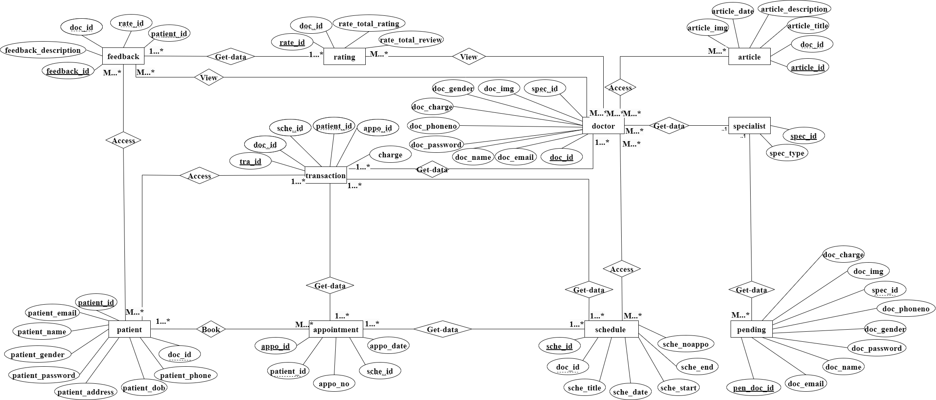

1. **DFD [DATA FLOW DIAGRAM] :**
   1. 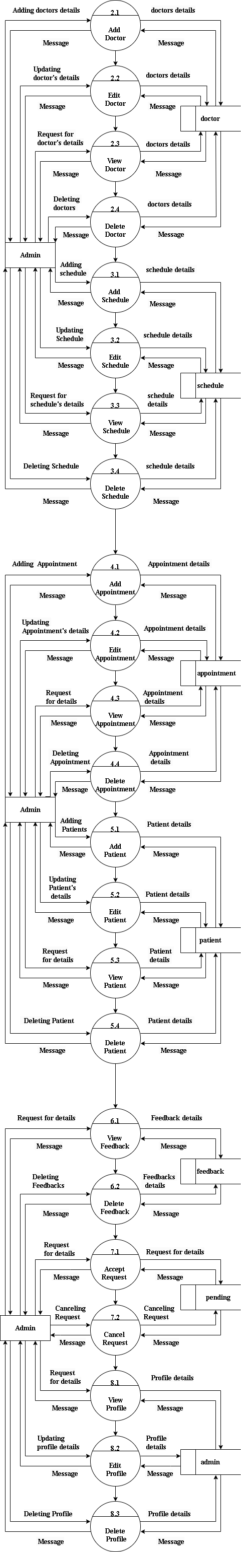**ADMIN 2ND LEVEL :**

**To be Continue …**

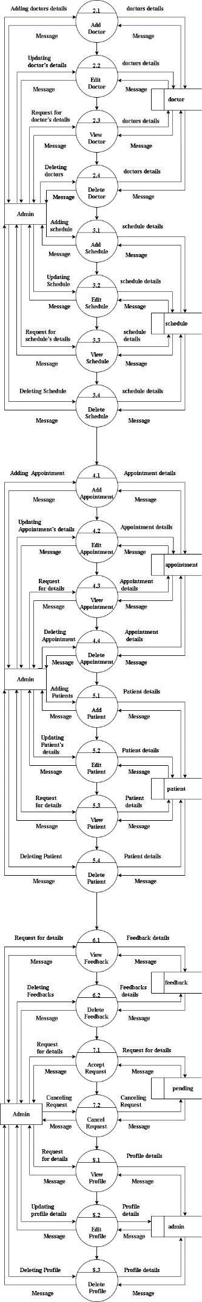**To Be Continue …**



1. **SCREEN SHORTS:**
   1. 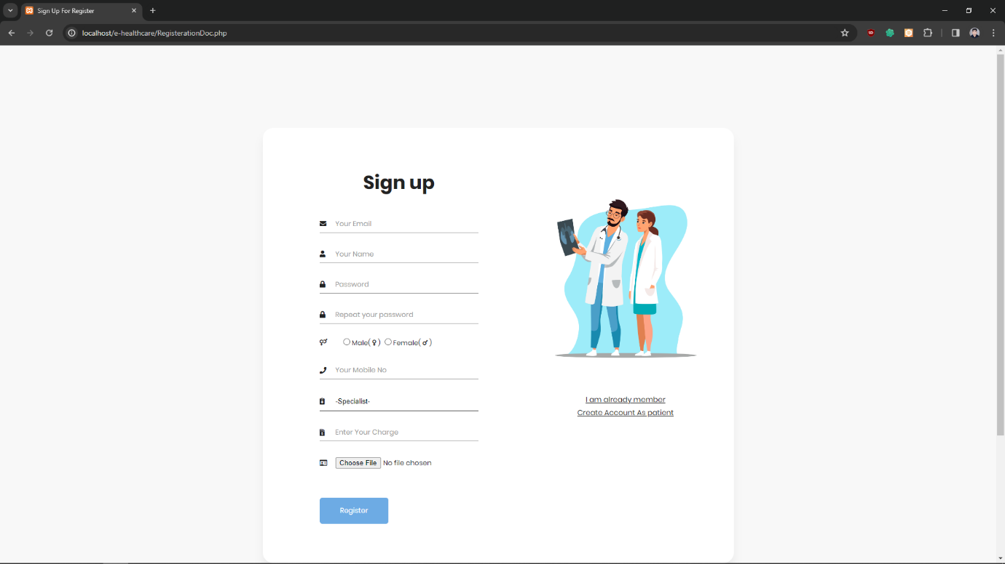**DOCTOR REGISTRATION :**

The doctor registration page in a healthcare system allows doctors to create an account and provide their personal and professional information. Doctors typically input their credentials, specialty, contact details, and availability on this page. The registration process may also involve verifying the doctor's credentials and licensing information. Once registered, doctors can access patient records, schedule appointments, and communicate with other healthcare professionals within the system. The doctor registration page plays a crucial role in ensuring that only qualified and licensed medical professionals have access to the healthcare system's resources and services.

* 1. **DOCTOR REGISTRATION CODE :**

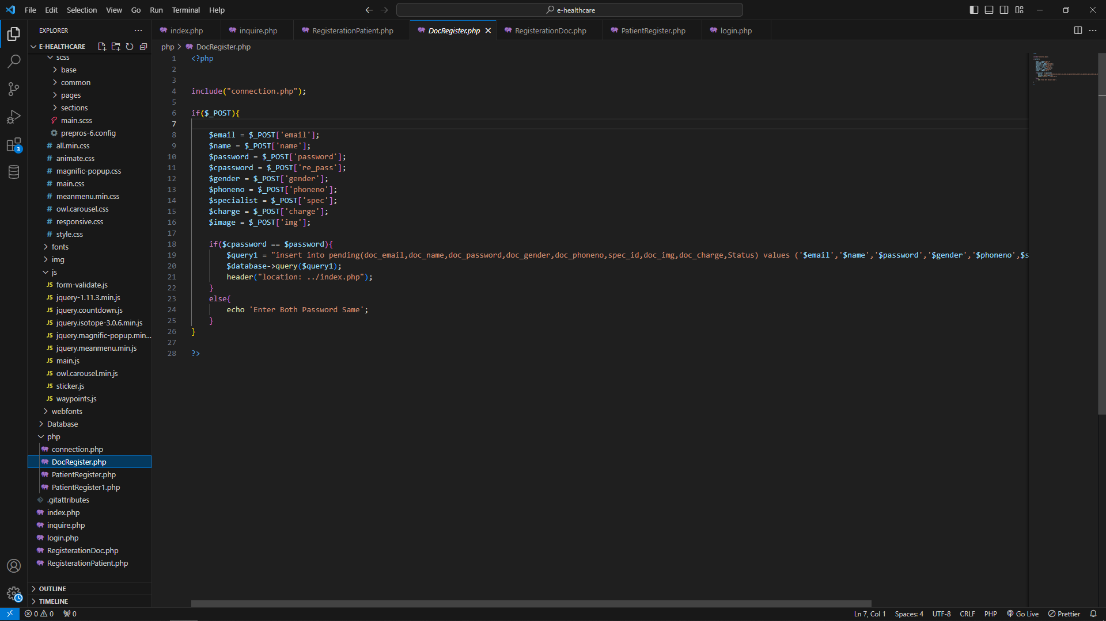

This Is Doctor Registration Code With That Doctor Details Are Being Stored In Pending Table For Get Request To Admin For approved Or Not This Is Very Simple Code With That data Store In database.

* 1. **DOCTOR LIST :**

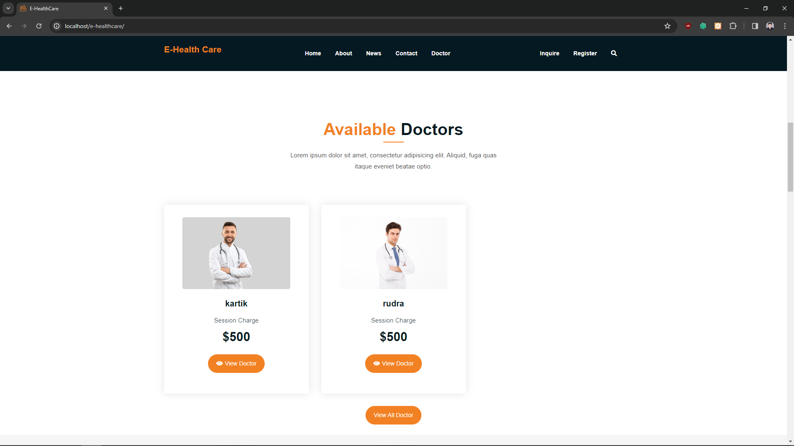

The Doctor list page in a healthcare management system displays a comprehensive list of all registered doctors within the system. It provides essential information such as doctor's name,charges and Allowed to view their all details.

* 1. 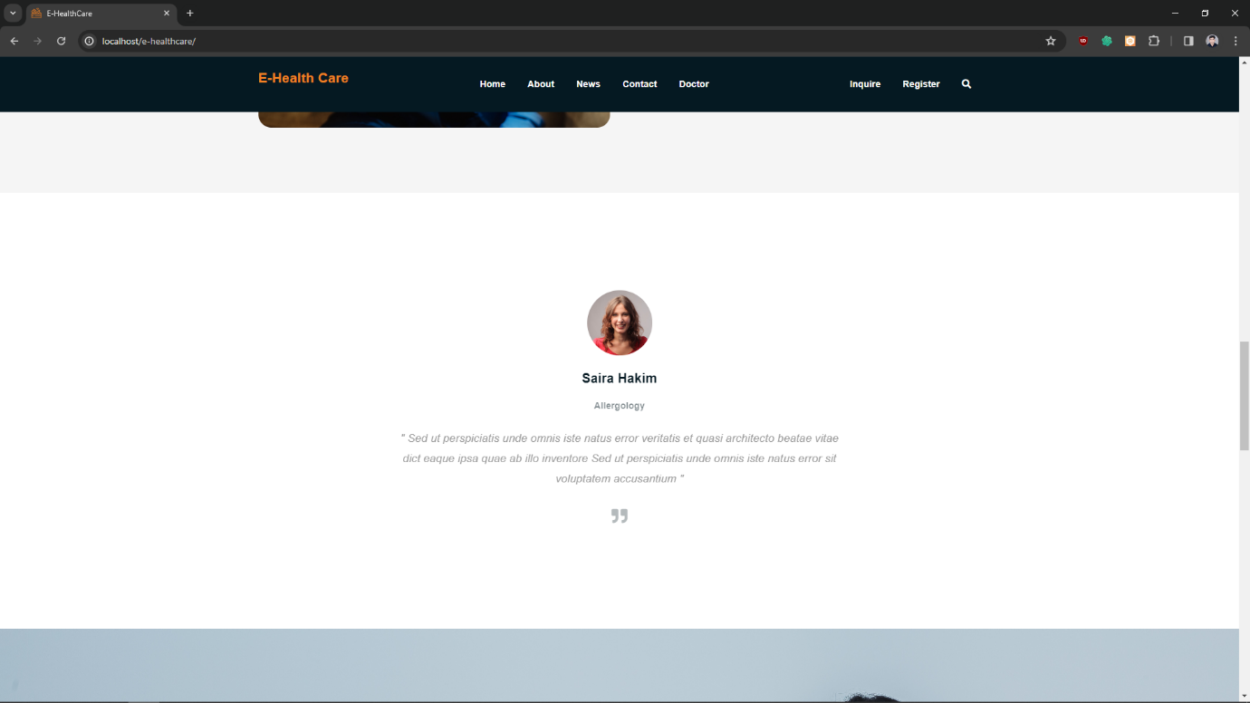**DOCTOR SUGGETION :**

This Is Detail On Index Page In which There Is Show Some Short Suggetion Of Doctor On particular Topic or decieas .With That Patient Get Some Small Knowledge Of Any Problem .

* 1. **ARTICLE PAGE :**

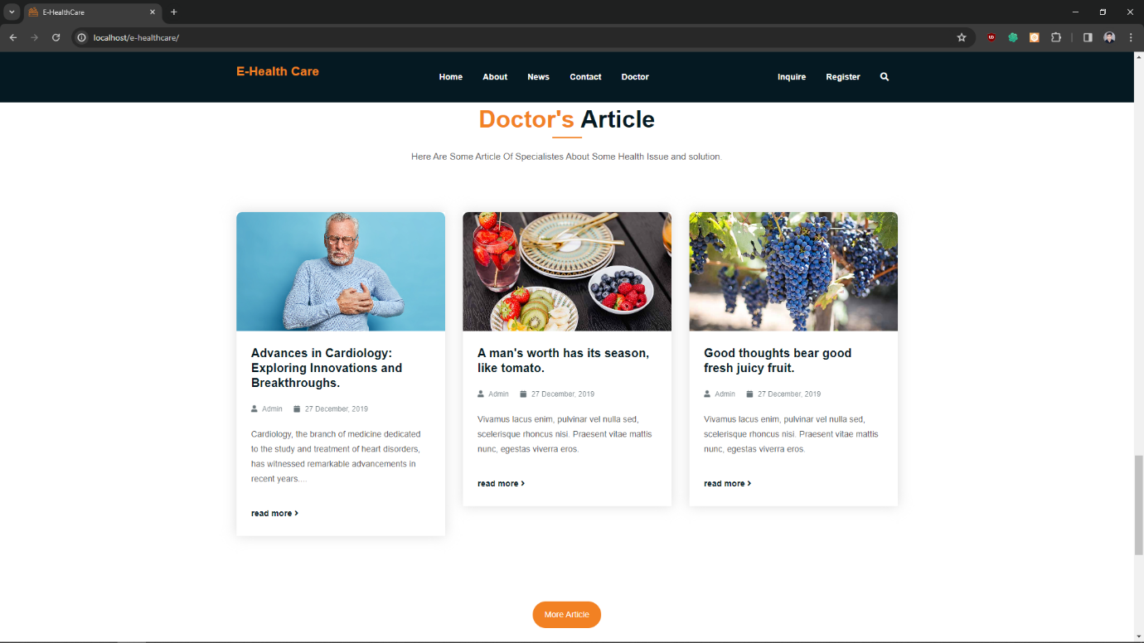

This Is Small Reference Portion Of Article Page With That Patient Get Information On Any Topic That Upload BY doctor And This Is Very Usefull When Doctor Want’s to share Some Details With People .

Here Is Option More Article With That It Reference To Article Page where Multiple Article Are Displayed .

* 1. 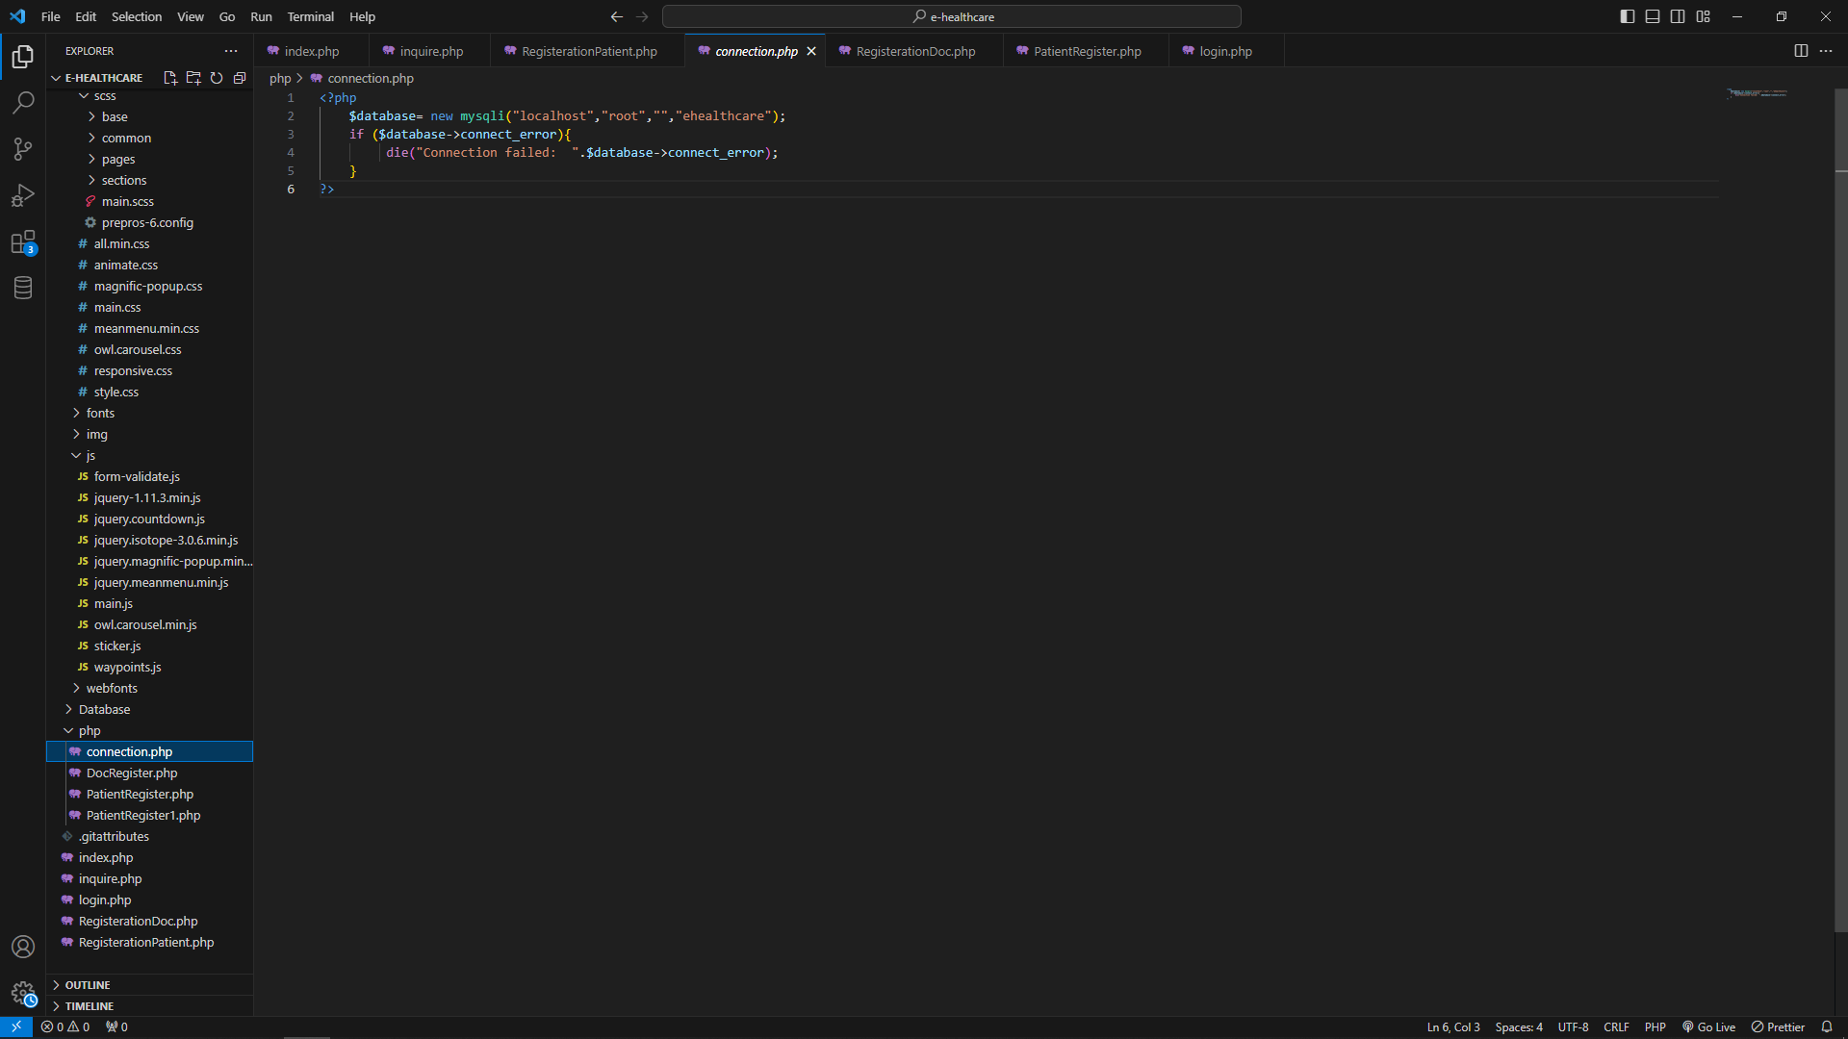**CONNECTION :**

This Is Very Important And Heart Of Website With That All Page Connect to The database This is Page Where database is connect to website with help of PHP.

* 1. 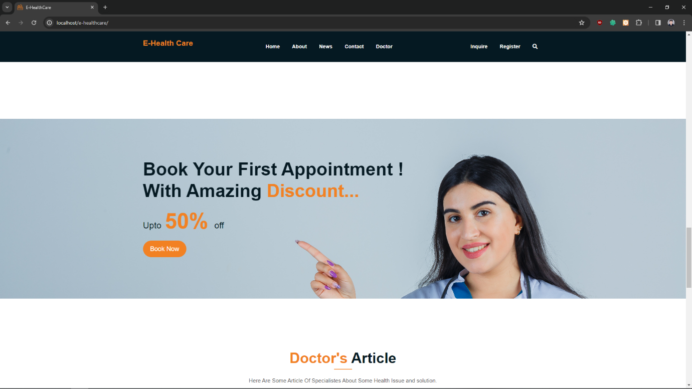**DISCOUNT :**

This Is Small Part in Home or index Page where It Is Just A Static Information For Those Patient For Getting Discount Of 50% on first Appointment.

Book now option click that will redirect User TO schedule page and than book appointment and get 50% or more discount.